Module Revisions
Module 1: Getting Started |  | Proofreader: Tina/Martina
 | Page Title: | Page Section: | Error:
Spelling/Grammar
Links to External Sites, Transcripts & Documents
Interactions (H5P, Storyline, Videos)
Other

Module 2: Citizenship |  | Proofreader: Valerie
 | Page Title: | Page Section: | Error:
Spelling/Grammar  Changed in all modules | Citizenship – Working with Words | “After you have studied the word and definitions from the overview page test your knowledge by completing the activity below. Good luck!” | Change to:  “After you have studied the words and definitions from the Overview page, test your knowledge by completing the activity below. Good luck!”
Changed in all modules | Citizenship – Working with Words | “Click the Previous button to return to the Digital Citizenship Overview page. Click the Next button to begin the first Learning Lab. | Consider changing to:  “Click the Previous button (below) to return to the Digital Citizenship Overview page. Click the Next button to begin the first Learning Lab.”
 | Being A Responsible Citizen | Obligations and Responsibilities of Citizens | Reformat the text so that it is easier to read. Consider:  Each citizen in the United States has certain obligations and responsibilities. Both the government and citizens are responsible for:  - protecting the rights of individuals and  - promoting the common good.  When citizens meet their obligations and fulfill their responsibilities they are making communities safer and better.  Check out the list of obligations and responsibilities below. Then, practice what you have learned by playing For the Common Good game.  - By attending civic meetings, a citizen can be heard by public officials (for example, attending a city council meeting or neighborhood watch group).  - Community service helps the common good. It benefits everyone when a citizen sees a need in his or her community and takes that extra step to find the solution.  - Defending the nation benefits the entire country and protects the nation from those who might wish to harm us.  - Paying taxes ensures that the government has funds to pay for large programs that benefit everyone (roads, schools and libraries, among others)  - By participating in jury duty, citizens are protecting the constitutional right of trial by jury.  - Obeying laws keeps order so that people are safe.  - Petitioning the government allows citizens to share their opinions with the government and ask for help with solving problems.  - Voting relates to the common good because it is one way for citizens to be heard by the leaders who represent them.
 | Summary of Citizenship Module |  | Rework:  “We are all connected in a way that our ideas and values affect each other and we may rely on each other in times of need.”
 | Being A Responsible Citizen | Obligations and Responsibilities of Citizens | “Then, practice what you have learned by playing For the Common Good game.”
Links to External Sites, Transcripts & Documents | Being A Responsible Citizen | Teen Spotlight - video | Change transcript setting so editing is not allowed.
 | Local and Global Citizenship - Overview | Learning Labs | Correct “Being a Citizen” link (assignment) to redirect to “Being a Responsible Citizen” page.
 | Being A Responsible Citizen | Globalization - video | Change transcript setting so editing is not allowed.
Any ideas would be appreciated. | Being A Responsible Citizen | Virtual Community | This link takes us to a 6 minute video that only plays to minute 3:20 without joining. ☹
 | Being A Responsible Citizen | Obligations and Responsibilities of Citizens | “Then, practice what you have learned by playing For the Common Good game.”  -----  Where is the For the Common Good game?
 | What is Digital Citizenship? | Online Safety | Video needs a transcript. No dialog in this video, so no transcript needed. (KS)
 | Test Your Digital Compass | Introducing Digital Compass | Video needs a transcript. Transcript created and uploaded to Monday board Mod2LP3. (KS)
 | Who Would You Hire | Linda’s Profile: Document 1 of 4 | This link is broken. Intentional?  “p.s.— Check out my blog at http://www.onlinediary.com/lindacooks”
 | Who Would You Hire | Jason’s Profile: Document 3 of 4 | After Title: the “J” in Jason should not be bolded.
Interactions (H5P, Storyline, Videos) | Test Your Citizenship Knowledge | Obligations and Responsibilities | Game is not loading. Black screen:  Also, change the name of the game to "For the Common Good" so that it matches up with directions on the prior page.
 | Who Would You Hire? | Trillion Dollar Footprint | Embed code is visible
 | What is Digital Citizenship? | Online Etiquette | Embed code is visible
 | What is Digital Citizenship? | Digital Footprint | Embed code is visible
Other | Overview &  Design Challenge Pages | Design Challenge | Not an error: Just a reminder to add Design Challenge. Change wording to “Challenge Your Mind”

Module 3: Personal Interests & Financial Literacy |  |  | Proofreader: Valerie
 | Page Title: | Page Section: |  | Error:
Spelling/Grammar | Working with Words for Personal Interests and Finances |  |  | Capitalize the “O” in Overview page
Links to External Sites, Transcripts & Documents | Financial Literacy | Personal Finance / Mission: Possible |  | Duplicated here, also found in Lesson 5.3: “Read to learn about the Small Business Administration. Then, create 3 or more #hashtags summarizing the mission of the Small Business Administration. (10 minutes) Ex: #Competition #Innovation #Opportunity”  If keeping it here as well, add the link to SBA. (Missing the link to the SBA website for the hashtag activity.)
 | Personal Interests & Financial Literacy Overview | Learning Labs |  | The Financial Literacy page links to a incomplete page - https://browardschools.instructure.com/courses/455677/pages/personal-finances/edit
Do they need to be changed? | Personal Interests | Under Teen Spotlight |  | Transcript allows me to edit in Word.
 | Financial Literacy | Under Teen Spotlight |  | Transcript allows me to edit in Word.
 | Personal Interests | Lesson Reflection |  | ‘text evidence’ to ‘textual evidence’
 | Article Drag and Drop | Under drag and drop |  | “Click here to return to the personal finance learning lab activities.”  Link takes you to the incomplete Financial Literacy page.
Interactions (H5P, Storyline, Videos) | Working with Words for Personal Interests and Finances | Personal Interests & Finances Vocabulary Practice |  | Vocabulary interaction shows as a gray screen.
Other | Summary of Personal Interests and Financial Literacy | top |  | “Congratulations! You completed the module on citizenship Personal Interests and Financial Literacy. All you need to do is answer the question below.”
 | Overview &  Design Challenge Pages | Design Challenge |  | Not an error: Just a reminder to add Design Challenge. Change wording to “Challenge Your Mind”

Module 4: Career Exploration |  | Proofreader: Kim
 | Page Title: | Page Section: | Error:
Spelling/Grammar | Goods and Services Defined | Introduction to goods and services | In speech bubble: “there’s are”, change to “there are”.
1. Martina’s h5p. Can we add 2 columns and an image on the right of teen spotlight?  2. Can we take 1 word out of the vocab. Memory game so it’s 3 rows.  3. Unpublish Business Structures lesson? If so, also summary question, scope and sequence, etc. If no, add a 2nd column image TS | Exploring Careers in STEM | Check Your Business Structure Knowledge | “Which business structures so owners have limited liability for business debts and obligations.”  Change to: “In which business structures do owners have limited liability for business debts and obligations?”
 | Exploring Careers in STEM | Module Summary | “would like in your future.” There is an extra space between “in” and “your”
Links to External Sites, Transcripts & Documents | Good and Services Defined | Mind Mapping Option 2 | “Resources” link and “bubbl.us” link both go to the same site.
Interactions (H5P, Storyline, Videos) | Goods and Services Defined | Introduction to goods and services | Speech bubble goes by too fast, not enough time to read text.
Other | Buying Good and Services | Top of page | Narrative is repeated twice. Once above the yellow banner and again below the yellow banner.

Module 5: Introduction to Entrepreneurship |  |  | Proofreader: Kim
 | Page Title: | Page Section: |  | Error:
Spelling/Grammar |  |  |  | NONE
Links to External Sites, Transcripts & Documents | Entrepreneurs Like Me | Biz Kids |  | 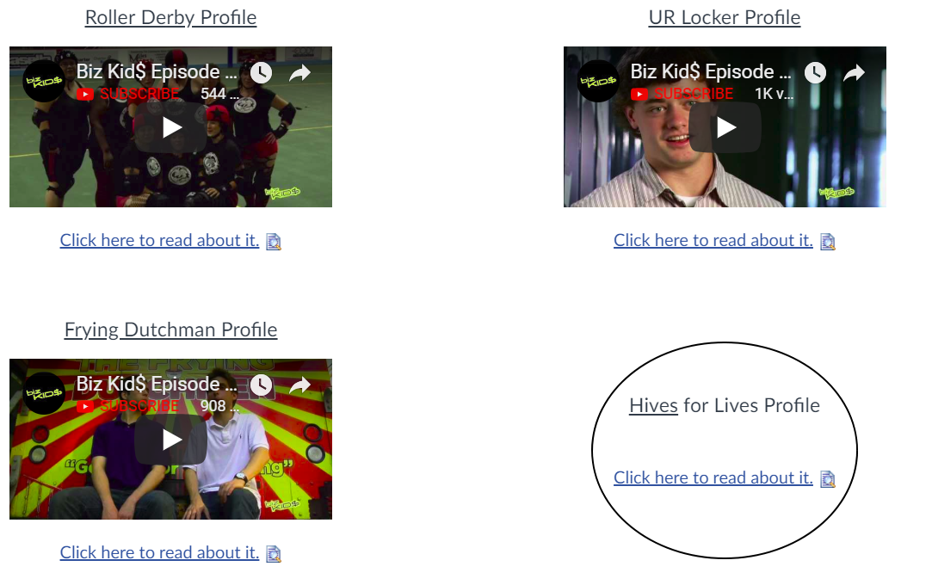
Interactions (H5P, Storyline, Videos) |  |  |  | NONE
Other |  |  |  | NONE

Module 6: Business Planning |  | Proofreader: Tina/Martina
 | Page Title: | Page Section: | Error:
Spelling/Grammar
Links to External Sites, Transcripts & Documents
Interactions (H5P, Storyline, Videos)
Other

Module 7: Business Website |  | Proofreader: Tina/Martina
 | Page Title: | Page Section: | Error:
Spelling/Grammar
Links to External Sites, Transcripts & Documents
Interactions (H5P, Storyline, Videos)
Other

Module 8: Community Involvement |  | Proofreader: Tina/Martina
 | Page Title: | Page Section: | Error:
Spelling/Grammar
Links to External Sites, Transcripts & Documents
Interactions (H5P, Storyline, Videos)
Other

